**Circular Linked List**

* Circular linked list is slightly differing from regular linked lists.
* In Circular linked list, Last element points to First element.
* Both Single linked list and Double linked list can be made into a circular linked list.

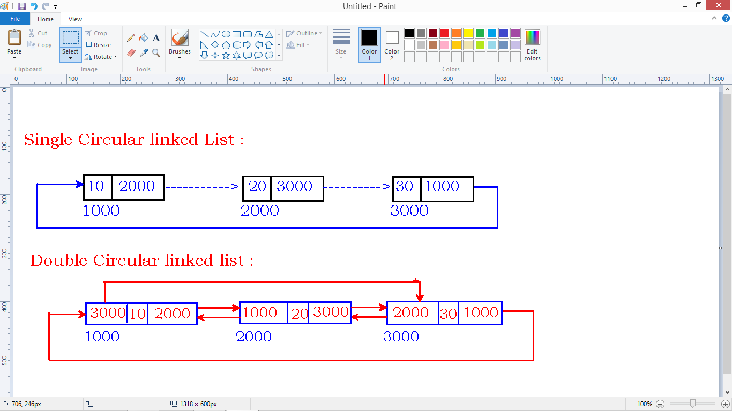

**Operations:**

* Insertion
* Deletion
* Display

**Node structure:**

struct Node

{

int data;

struct Node *next;

};

struct Node* head=NULL;

**Insertion:**

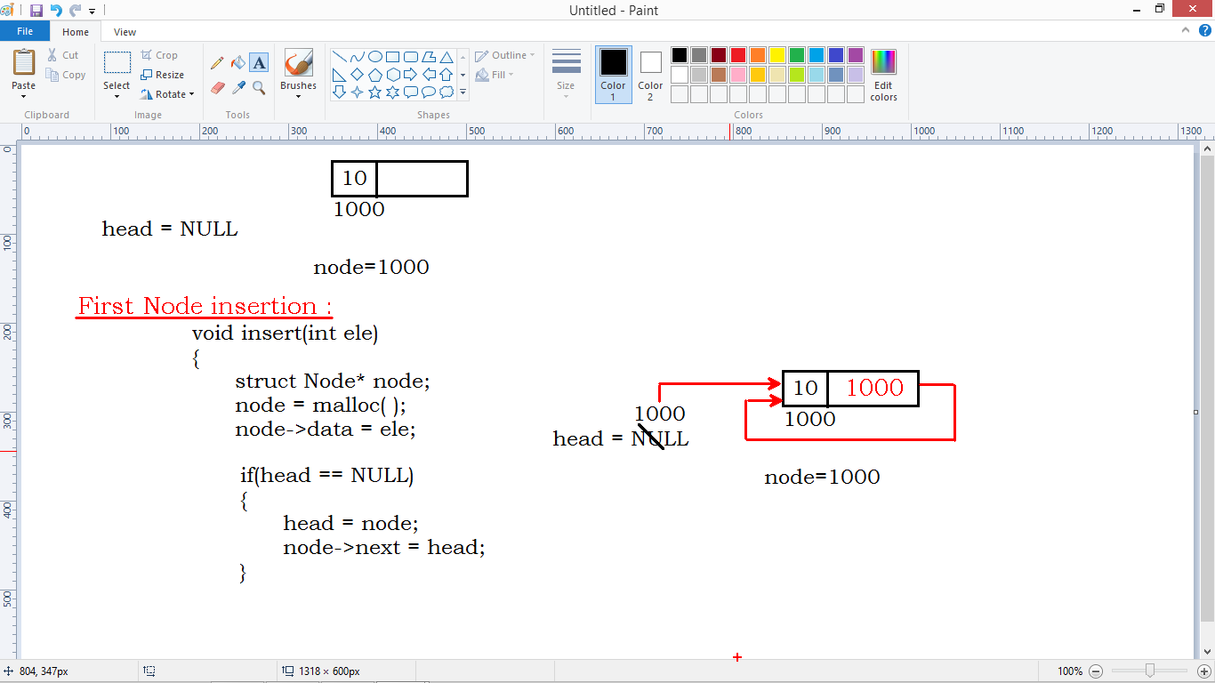

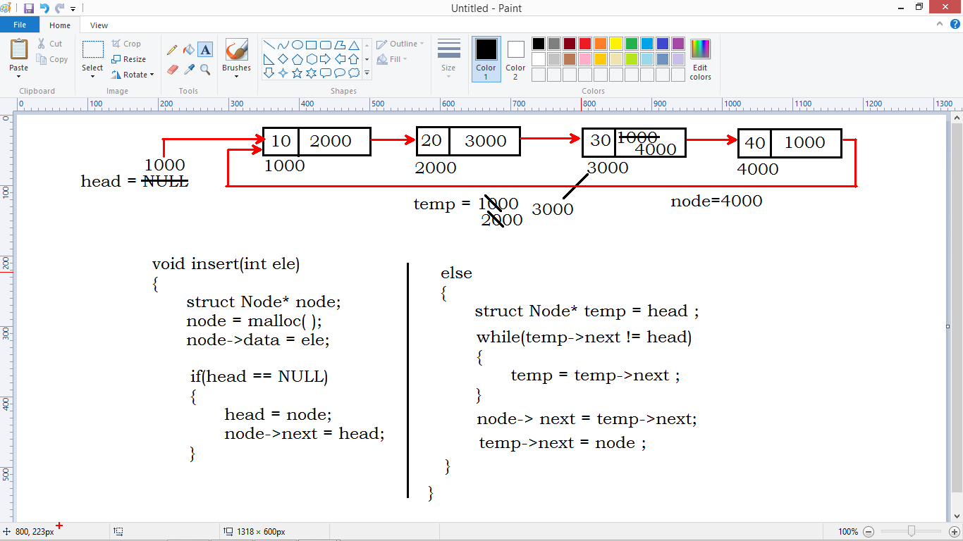

**Display:**

